Лабораторна робота № 9
Мета: Набути навиків створення нащадків класів. Засвоєння принципу ( наслідування( спадковості) в ООП(C#).

Завдання 1
«Каток»
Katok.cs
using System;
using System.Collections.Generic;
using System.ComponentModel;
using System.Data;
using System.Drawing;
using System.Linq;
using System.Text;
using System.Threading.Tasks;
using System.Windows.Forms;

namespace lr9_1
{
public partial class Katok : UserControl
{
public Point[] P;
int[] dx;
int[] dy;
Random R = new Random();
int n;
public Katok(int N)
{
InitializeComponent();
n = N;
P = new Point[N];
dx = new int[N];
dy = new int[N];
for (int i = 0; i < N; i++)
{
P[i].X = R.Next(Width);
P[i].Y = R.Next(Height);

do { dx[i] = R.Next(6) - 3; } while (dx[i] == 0);
do { dy[i] = R.Next(6) - 3; } while (dy[i] == 0);
}
timer1.Start();
}
private void timer1_Tick(object sender, EventArgs e)
{
for (int i = 0; i < n; i++)
{
P[i].X += dx[i];
P[i].Y += dy[i];
if ((P[i].X < 3) || (P[i].X > Width - 3))
dx[i] = -dx[i];
if ((P[i].Y < 3) || (P[i].Y > Height - 3))
dy[i] = -dy[i];
if (P[i].X > Width - 3) P[i].X = Width - 3;
if (P[i].Y > Height - 3) P[i].Y = Height - 3;
}
Invalidate();
}
private void Katok_Paint(object sender, PaintEventArgs e)
{
e.Graphics.DrawPolygon(Pens.DeepPink, P);
}
}
}

Form1
namespace lr9_1
{
public partial class Form1 : Form
{
Katok K;
public Form1()
{
InitializeComponent();
Random R = new Random();
K = new Katok(R.Next(3, 8));
K.Parent = this;
K.Size = ClientSize;
K.Anchor = (AnchorStyles.Bottom |
AnchorStyles.Left |
AnchorStyles.Right |
AnchorStyles.Top);
}
}
}

Результат
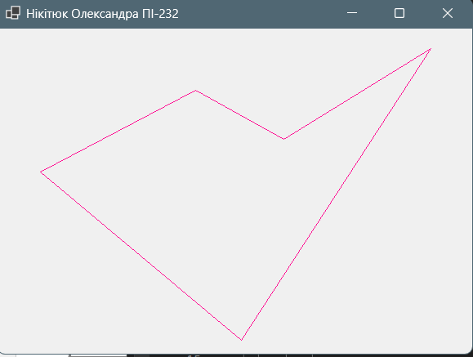

Завдання 2
Polotno.cs
using System;
using System.Collections.Generic;
using System.Drawing;
using System.Windows.Forms;

namespace lr9_2
{
public class Polotno : UserControl
{
private const int CellSize = 20;
public Color ActiveColor { get; set; } = Color.Black;
public int symm { get; set; } = 0;
public bool IsFillMode { get; set; } = false;
private List<(Point pos, Color col)> pixels = new List<(Point, Color)>();
public Polotno()
{
DoubleBuffered = true;
BackColor = Color.White;
MouseClick += Polotno_MouseClick;
}
protected override void OnPaint(PaintEventArgs e)
{
base.OnPaint(e);
foreach (var p in pixels)
{
using (SolidBrush br = new SolidBrush(p.col))
{
e.Graphics.FillRectangle(br, p.pos.X * CellSize, p.pos.Y * CellSize, CellSize, CellSize);
}
e.Graphics.DrawRectangle(Pens.Gray, p.pos.X * CellSize, p.pos.Y * CellSize, CellSize, CellSize);
}
}
private void Polotno_MouseClick(object? sender, MouseEventArgs e)
{
int x = e.X / CellSize;
int y = e.Y / CellSize;
AddPixel(x, y, ActiveColor);
ApplySymmetry(x, y);
Invalidate();
}
private void AddPixel(int x, int y, Color c)
{
if (x < 0 || y < 0) return;
pixels.RemoveAll(p => p.pos.X == x && p.pos.Y == y);
pixels.Add((new Point(x, y), c));
}
private void ApplySymmetry(int x, int y)
{
int maxX = Width / CellSize;
int maxY = Height / CellSize;
switch (symm)
{
case 1:
AddPixel(maxX - x - 1, y, ActiveColor);
break;
case 2:
AddPixel(x, maxY - y - 1, ActiveColor);
break;
case 3:
AddPixel(maxX - x - 1, y, ActiveColor);
AddPixel(x, maxY - y - 1, ActiveColor);
AddPixel(maxX - x - 1, maxY - y - 1, ActiveColor);
break;
case 4:
AddPixel(maxX - x - 1, maxY - y - 1, ActiveColor);
break;
}
}
public void Clear()
{
pixels.Clear();
Invalidate();
}
public void SaveToFile(string path) { }
public void LoadFromFile(string path) { }
public void SaveAsImage(string path) { }
public void PrintPattern() { }
}
}

Form1
using System;
using System.Windows.Forms;

namespace lr9_2
{
public partial class Form1 : Form
{
public Form1()
{
InitializeComponent();
}
private void buttonColor_Click(object sender, EventArgs e)
{
if (colorDialog1.ShowDialog() == DialogResult.OK)
polotno1.ActiveColor = colorDialog1.Color;
}
private void rbHoriz_CheckedChanged(object sender, EventArgs e)
{
polotno1.symm = 2;
}
private void rbVert_CheckedChanged(object sender, EventArgs e)
{
polotno1.symm = 1;
}

private void rbBoth_CheckedChanged(object sender, EventArgs e)
{
polotno1.symm = 3;
}
private void rbCenter_CheckedChanged(object sender, EventArgs e)
{
polotno1.symm = 4;
}
private void rbNone_CheckedChanged(object sender, EventArgs e)
{
polotno1.symm = 0;
}
private void buttonClear_Click(object sender, EventArgs e)
{
polotno1.Clear();
}
private void btnSave_Click(object sender, EventArgs e)
{
SaveFileDialog sfd = new SaveFileDialog();
sfd.Filter = "Stitch Project|*.stitch";
if (sfd.ShowDialog() == DialogResult.OK)
polotno1.SaveToFile(sfd.FileName);
}
private void btnLoad_Click(object sender, EventArgs e)
{
OpenFileDialog ofd = new OpenFileDialog();
ofd.Filter = "Stitch Project|*.stitch";
if (ofd.ShowDialog() == DialogResult.OK)
polotno1.LoadFromFile(ofd.FileName);
}
private void btnImage_Click(object sender, EventArgs e)
{
SaveFileDialog sfd = new SaveFileDialog();
sfd.Filter = "JPEG Image|*.jpg|PNG Image|*.png";
if (sfd.ShowDialog() == DialogResult.OK)
polotno1.SaveAsImage(sfd.FileName);
}
private void btnPrint_Click(object sender, EventArgs e)
{
polotno1.PrintPattern();
}
private void chkFill_CheckedChanged(object sender, EventArgs e)
{
polotno1.IsFillMode = chkFill.Checked;
}
private void rbPencil_CheckedChanged(object sender, EventArgs e)
{
if (rbPencil.Checked)
polotno1.IsFillMode = false;
}
}
}

Результат
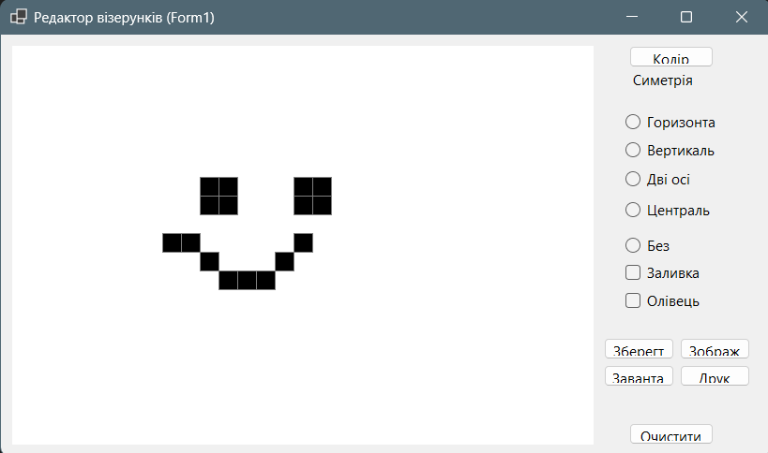

Завдання 3

Game.cs
using lr9_3;
using System;
using System.Drawing;
using System.Threading.Tasks;
using System.Windows.Forms;

namespace lr9_3
{
public class Game : UserControl
{
public Play Logic = new Play();
public event Action<string>? OnFinished;
private const int cell = 100;
private (Point start, Point end)? WinLine = null;

public Game()
{
this.Size = new Size(3 * cell, 3 * cell);
this.MouseClick += Game_MouseClick;
DoubleBuffered = true;
}
private async void Game_MouseClick(object? sender, MouseEventArgs e)
{
int r = e.Y / cell;
int c = e.X / cell;
if (r < 0 || r > 2 || c < 0 || c > 2) return;
if (!Logic.MakeMove(r, c)) return;
Invalidate();
string winner = Logic.CheckWinner();
if (winner != null)
{
CalculateWinLine();
Refresh
await Task.Delay(300);
OnFinished?.Invoke(winner);
return;
}
Logic.CurrentPlayer = Logic.CurrentPlayer == "X" ? "O" : "X";
Invalidate();
}
private void CalculateWinLine()
{
WinLine = null;
for (int i = 0; i < 3; i++)
{
if (Logic.Board[i, 0] != null &&
Logic.Board[i, 0] == Logic.Board[i, 1] &&
Logic.Board[i, 1] == Logic.Board[i, 2])
{
int y = i * cell + cell / 2;
WinLine = (new Point(10, y), new Point(3 * cell - 10, y));
return;
}
}
for (int i = 0; i < 3; i++)
{
if (Logic.Board[0, i] != null &&
Logic.Board[0, i] == Logic.Board[1, i] &&
Logic.Board[1, i] == Logic.Board[2, i])
{
int x = i * cell + cell / 2;
WinLine = (new Point(x, 10), new Point(x, 3 * cell - 10));
return;
}
}
if (Logic.Board[0, 0] != null &&
Logic.Board[0, 0] == Logic.Board[1, 1] &&
Logic.Board[1, 1] == Logic.Board[2, 2])
{
WinLine = (new Point(10, 10), new Point(3 * cell - 10, 3 * cell - 10));
return;
}
if (Logic.Board[0, 2] != null &&
Logic.Board[0, 2] == Logic.Board[1, 1] &&
Logic.Board[1, 1] == Logic.Board[2, 0])
{
WinLine = (new Point(3 * cell - 10, 10), new Point(10, 3 * cell - 10));
return;
}
}
protected override void OnPaint(PaintEventArgs e)
{
base.OnPaint(e);
var g = e.Graphics;
g.DrawLine(Pens.Black, cell, 0, cell, 3 * cell);
g.DrawLine(Pens.Black, 2 * cell, 0, 2 * cell, 3 * cell);
g.DrawLine(Pens.Black, 0, cell, 3 * cell, cell);
g.DrawLine(Pens.Black, 0, 2 * cell, 3 * cell, 2 * cell);
for (int r = 0; r < 3; r++)
{
for (int c = 0; c < 3; c++)
{
var s = Logic.Board[r, c];
if (s == "X")
{
g.DrawLine(Pens.Red, c * cell + 20, r * cell + 20, c * cell + 80, r * cell + 80);
g.DrawLine(Pens.Red, c * cell + 80, r * cell + 20, c * cell + 20, r * cell + 80);
}
else if (s == "O")
{
g.DrawEllipse(Pens.Blue, c * cell + 20, r * cell + 20, 60, 60);
}
}
}
if (WinLine != null)
{
using (var pen = new Pen(Color.Green, 6))
{
g.DrawLine(pen, WinLine.Value.start, WinLine.Value.end);
}
}
}
public void Restart()
{
Logic.Reset();
WinLine = null;
Invalidate();
}
}
}

Play.cs
using System;

namespace lr9_3
{
public class Play
{
public string[,] Board = new string[3, 3];
public string CurrentPlayer = "X";
public void Reset()
{
Board = new string[3, 3];
CurrentPlayer = "X";
}
public bool MakeMove(int r, int c)
{
if (Board[r, c] != null) return false;
Board[r, c] = CurrentPlayer;
return true;
}
public string CheckWinner()
{
for (int i = 0; i < 3; i++)
{
if (Board[i, 0] != null &&
Board[i, 0] == Board[i, 1] &&
Board[i, 1] == Board[i, 2])
return Board[i, 0];
if (Board[0, i] != null &&
Board[0, i] == Board[1, i] &&
Board[1, i] == Board[2, i])
return Board[0, i];
}
if (Board[0, 0] != null &&
Board[0, 0] == Board[1, 1] &&
Board[1, 1] == Board[2, 2])
return Board[0, 0];
if (Board[0, 2] != null &&
Board[0, 2] == Board[1, 1] &&
Board[1, 1] == Board[2, 0])
return Board[0, 2];
return null;
}
}
}

Form1
using lr9_3;
using System;
using System.Windows.Forms;

namespace lr9_3
{
public partial class Form1 : Form
{
public Form1()
{
InitializeComponent();
game1.OnFinished += GameFinished;
}
private void GameFinished(string winner)
{
MessageBox.Show(this, $"Переможець: {winner}", "Гра", MessageBoxButtons.OK, MessageBoxIcon.Information);
}

private void btnStart_Click(object sender, EventArgs e)
{
game1.Restart();
}
}
}

Результат
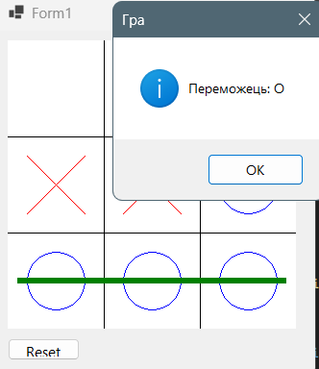

Висновок: Набула навики створення нащадків класів. Засвоїла принцип ( наслідування( спадковості) в ООП(C#).

